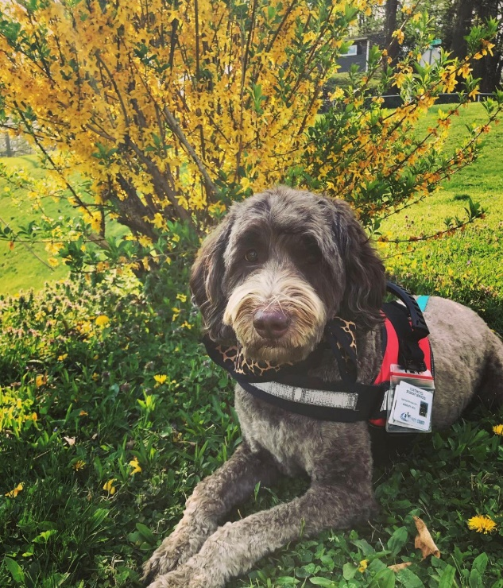

**Safe Haven, Therapy Dog**

Spring Hill Elementary welcomed a new staff member to join the team in the Fall of 2017.  Safe Haven is a registered therapy dog who works primarily alongside our school counselor, Beth Pettry.  Haven is a Labradoodle, which makes her coat hypoallergenic.  She has proven that her role is essential at Spring Hill Elementary for reducing student behavior referrals and suspension rates. Safe Haven, our canine friend, visits with students who may be experiencing stress in their personal lives, or who might just need help calming their nerves before a big test.  In the process, she demonstrates to everyone school-wide we are all more alike than we may realize. Staff and students at SHE benefit daily from Haven's unconditional love and kindness.